In the Name of God



Navid Zare

40435071

Fuzzy Sets & Logic
TSK Fuzzy System for Predicting Asphalt Strength, Deformation, and Performance Properties

خلاصه فارسی
این گزارش طراحی و پیاده‌سازی یک سیستم استنتاج فازی تاکاگی-سوگنو-کانگ (TSK) مرتبه اول برای پیش‌بینی خواص مقاومتی، تغییر شکل و عملکرد آسفالت را ارائه می‌دهد. هدف اصلی این پروژه توسعه یک ابزار محاسباتی است که بتواند بدون نیاز به آزمایش‌های گسترده آزمایشگاهی، کیفیت روسازی و یکپارچگی سازه‌ای جاده‌ها را ارزیابی کند. این سیستم چهار متغیر خروجی را پیش‌بینی می‌کند: استابیلیتی تعدیل‌شده (کیلونیوتن)، روانی (میلی‌متر)، مدول سختی کششی غیرمستقیم در دمای ۲۰ درجه سانتیگراد (ITSM20) و در دمای ۳۰ درجه سانتیگراد (ITSM30).
مجموعه داده مورد استفاده شامل ۱۶۸ نمونه مخلوط آسفالتی است که هر کدام با ۱۰ متغیر ورودی و ۴ متغیر خروجی مشخص شده‌اند. متغیرهای ورودی شامل: ویسکوزیته قیر (پاسکال-ثانیه)، درصد آسفالت به وزن کل (Pb)، درصد آسفالت مؤثر (Pbe)، وزن مخصوص تئوریکی حداکثر (Gmm)، درصد فضای خالی هوا (Va)، وزن واحد حجم (کیلوگرم بر متر مکعب)، و پارامترهای دانه‌بندی سنگدانه‌ها (P200، P4، P38، P34) می‌باشند. داده‌ها به نسبت ۸۰-۲۰ به مجموعه‌های آموزش (۱۳۴ نمونه) و آزمون (۳۴ نمونه) تقسیم شدند.
روش طراحی سیستم شامل سه مرحله اصلی است. در مرحله اول، تولید خودکار قواعد فازی با استفاده از الگوریتم خوشه‌بندی تفاضلی (Subtractive Clustering) در فضای مشترک ورودی-خروجی انجام می‌شود. این الگوریتم با محاسبه پتانسیل هر نقطه داده و انتخاب تکراری نقاط با بیشترین پتانسیل به عنوان مرکز خوشه، ساختار قواعد را تعیین می‌کند. پارامترهای خوشه‌بندی شامل شعاع خوشه (۱.۲)، ضریب فشردگی (۱.۲۵)، نسبت پذیرش (۰.۵) و نسبت رد (۰.۱۵) می‌باشند.
در مرحله دوم، توابع عضویت گاوسی برای هر متغیر ورودی در هر قاعده تعریف می‌شود. تابع عضویت گاوسی به صورت μ(x) = exp(-0.5×((x-c)/σ)²) تعریف می‌شود که در آن c مرکز و σ انحراف معیار است. مراکز اولیه از مراکز خوشه‌ها و انحراف معیارها به صورت σ = rₐ/√8 مقداردهی اولیه می‌شوند.
در مرحله سوم، بهینه‌سازی پارامترها با استفاده از یک الگوریتم یادگیری ترکیبی انجام می‌شود. پارامترهای مقدم (مراکز و انحراف معیارهای توابع عضویت) با روش گرادیان کاهشی با نرخ یادگیری ۰.۰۱ به‌روزرسانی می‌شوند. پارامترهای تالی (ضرایب توابع خطی) با روش حداقل مربعات منظم‌شده (رگرسیون ریج با λ=۰.۰۱) برآورد می‌شوند. آموزش تا ۸۰۰ دوره ادامه می‌یابد یا زمانی که بهبود RMSE کمتر از ۱۰⁻⁸ شود متوقف می‌گردد.
نتایج تجربی نشان‌دهنده قابلیت پیش‌بینی مؤثر سیستم می‌باشد. الگوریتم خوشه‌بندی به طور خودکار ۱۲ قاعده برای استابیلیتی و ۱۱ قاعده برای هر یک از سه خروجی دیگر تعیین کرد. خطای ریشه میانگین مربعات (RMSE) روی داده‌های آزمون برابر است با: ۱.۰۵۷ کیلونیوتن برای استابیلیتی، ۰.۷۸۵ میلی‌متر برای روانی، ۵۷۶.۶۷ مگاپاسکال برای ITSM20، و ۱۸۴.۵۵ مگاپاسکال برای ITSM30. این مقادیر خطا برای کاربردهای مهندسی قابل قبول است.
منحنی‌های همگرایی آموزش نشان‌دهنده کاهش پایدار و یکنواخت خطا در طول همه دوره‌های آموزش برای تمام چهار سیستم فرعی TSK می‌باشد. نمودارهای پراکندگی مقادیر پیش‌بینی‌شده در مقابل مقادیر واقعی همبستگی مثبت قوی را نشان می‌دهند. تجسم توابع عضویت الگوهای معناداری سازگار با تئوری مخلوط آسفالت را آشکار می‌سازد.
پیاده‌سازی از معماری ماژولار با هشت فایل پایتون پیروی می‌کند: config.py (تنظیمات)، data_loader.py (بارگذاری و نرمال‌سازی داده)، clustering.py (خوشه‌بندی تفاضلی)، membership_functions.py (توابع عضویت)، tsk_system.py (کلاس‌های قاعده و سیستم)، training.py (ساخت و بهینه‌سازی)، visualization.py (تولید نمودارها)، و results_writer.py (ذخیره نتایج). برای اجرا، پایتون ۳.۷ یا بالاتر نصب شود، وابستگی‌ها با pip install -r requirements.txt نصب گردد، و سپس python main.py اجرا شود.
در نتیجه‌گیری، این پروژه با موفقیت یک سیستم استنتاج فازی TSK برای پیش‌بینی خواص روسازی آسفالت طراحی و پیاده‌سازی کرد. سیستم توسعه‌یافته ابزار محاسباتی عملی برای مهندسان ساخت جاده فراهم می‌کند. ساختار مبتنی بر قواعد قابل تفسیر امکان اعتبارسنجی در برابر دانش تخصصی را فراهم می‌سازد. پیشنهاد برای کارهای آینده شامل استفاده از روش‌های انتخاب ویژگی، روش‌های ترکیبی (ensemble)، و ادغام با داده‌های عملکرد میدانی می‌باشد.

Abstract
This report presents the design and implementation of a Takagi-Sugeno-Kang (TSK) Fuzzy Inference System for predicting critical asphalt pavement properties. The system predicts four output variables: Adjusted Stability, Flow, Indirect Tensile Stiffness Modulus at 20°C (ITSM20), and ITSM at 30°C (ITSM30). The methodology employs subtractive clustering in joint input-output space to automatically determine the structure of fuzzy rules, followed by gradient descent optimization of antecedent membership function parameters and least-squares estimation of consequent parameters. The dataset comprises 168 asphalt mix samples characterized by 10 input variables describing binder properties, asphalt content, volumetric characteristics, and aggregate gradation. Experimental results demonstrate effective prediction capabilities with Root Mean Square Errors (RMSE) of 1.057 kN for Stability, 0.785 mm for Flow, 576.67 MPa for ITSM20, and 184.55 MPa for ITSM30 on the test dataset. The developed system provides a computational tool for road construction engineers to assess pavement quality and structural integrity without extensive laboratory testing.

1. Introduction

1.1 Problem Statement
Asphalt pavement performance is critical for infrastructure safety and longevity. The structural integrity of roads and highways depends on accurate characterization of asphalt mixture properties, including strength, deformation resistance, and stiffness under varying temperature conditions. Traditional laboratory testing methods, while accurate, require significant time and resources. Consequently, there exists a substantial need for predictive models capable of estimating these properties based on mixture composition and constituent characteristics.
The prediction of asphalt properties involves complex nonlinear relationships between input variables (binder viscosity, asphalt content, air voids, aggregate gradation) and output performance indicators. Fuzzy inference systems offer an effective approach to modeling such relationships, as they can capture uncertainty and provide interpretable rule-based representations of the underlying physical phenomena. The TSK fuzzy system, in particular, combines the interpretability of fuzzy rules with the precision of linear consequent functions, making it well-suited for regression problems in engineering applications.

1.2 Objectives
The primary objective of this project is to design and implement a first-order TSK fuzzy inference system capable of predicting four key asphalt properties from mixture composition data. The specific objectives include: developing an automated rule generation mechanism using subtractive clustering, implementing a hybrid learning algorithm combining gradient descent for antecedent parameters and least-squares estimation for consequent parameters, evaluating the system performance using RMSE metrics on both training and test datasets, and providing a practical tool for end-user application in pavement engineering contexts.

2. Dataset Description
The dataset utilized in this study comprises 168 asphalt mixture samples, each characterized by 10 input variables and 4 output variables. The input variables encompass comprehensive information about binder properties, asphalt content parameters, volumetric properties, and aggregate gradation characteristics. The output variables represent key mechanical performance indicators obtained through Marshall testing and indirect tensile stiffness modulus measurements.

2.1 Input Variables
Viscosity (η) measured in Pascal-seconds (Pa·s) quantifies the resistance to flow of the asphalt binder. Higher viscosity values indicate stiffer binders with improved rutting resistance but reduced workability during compaction. The percentage of Asphalt Cement by weight (Pb) represents the total binder content in the mixture, which is critical for durability, strength, and moisture resistance. The Effective Asphalt Content (Pbe) denotes the portion of binder not absorbed by aggregates, representing the material that actively contributes to mixture strength and durability.
Maximum Theoretical Specific Gravity (Gmm) represents the density of the asphalt mixture with zero air voids, serving as a reference for calculating compaction degree. Unit Weight (kg/m³) measures the bulk density of the compacted mixture, where higher values generally indicate better compaction quality. Air Voids (Va) expressed as a percentage indicates the volume of air spaces within the compacted mixture, with typical design targets ranging from 3% to 5%. Values below this range may cause bleeding, while excessive air voids promote moisture damage and cracking.
The aggregate gradation parameters include P200 (percentage passing the 0.075 mm sieve), representing mineral filler content that influences stiffness and moisture sensitivity. P4 (cumulative percent retained on the 4.75 mm sieve) measures coarse aggregate content, while P38 (cumulative percent retained on the 9.5 mm sieve) indicates the overall coarse aggregate skeleton. P34 (cumulative percent retained on the 19 mm sieve) represents the largest aggregate size fraction contributing to mixture stability.

2.2 Output Variables
Adjusted Stability (kN) from the Marshall test represents the maximum load the specimen can withstand, indicating overall strength and resistance to rutting under traffic loading. Flow (mm) measures the deformation at maximum load, where high flow values suggest excessive softness and low values indicate brittleness. The Indirect Tensile Stiffness Modulus at 20°C (ITSM20) and at 30°C (ITSM30) characterize mixture stiffness under moderate and elevated temperature conditions respectively. Higher ITSM20 values correlate with improved rutting resistance, while ITSM30 values indicate susceptibility to permanent deformation under hot weather conditions.

2.3 Data Partitioning
Following the assignment specifications, the dataset was randomly partitioned into training and test subsets using an 80-20 split ratio with a fixed random seed of 42 for reproducibility. This resulted in 134 samples for training and fuzzy system tuning, and 34 samples reserved for independent testing. The stratified random sampling ensures representative distribution of samples across both subsets.
Table 1: Dataset Statistics
Parameter | Value
Total Samples | 168
Training Samples | 134 (80%)
Test Samples | 34 (20%)
Input Variables | 10
Output Variables | 4

3. Design Methodology

3.1 System Architecture
The implemented system follows the first-order Takagi-Sugeno-Kang (TSK) fuzzy inference architecture. Four separate TSK fuzzy systems were designed, one for each output variable, as permitted by the assignment specifications. This design decision was motivated by the different physical natures of the output variables and their potentially distinct relationships with the input features. Each system operates independently, allowing for tailored rule structures optimized for the specific output being predicted.
In a first-order TSK system, each fuzzy rule takes the form: IF x₁ is A₁ AND x₂ is A₂ AND ... AND xₙ is Aₙ THEN y = p₀ + p₁x₁ + p₂x₂ + ... + pₙxₙ. The antecedent part consists of fuzzy sets Aᵢ defined by Gaussian membership functions, while the consequent is a linear function of the input variables. The final output is computed as the weighted average of all rule consequents, where the weights are determined by the firing strengths of the rules.

3.2 Data Preprocessing
Prior to fuzzy system construction, all input and output variables were normalized to the [0, 1] range using Min-Max scaling. This preprocessing step is essential for subtractive clustering, as it ensures that all dimensions contribute equally to distance calculations regardless of their original measurement scales. The normalization parameters (minimum and maximum values) were fitted exclusively on the training data to prevent information leakage from the test set. Separate scalers were maintained for each output variable to enable proper inverse transformation of predictions back to original measurement units.

3.3 Fuzzy Rule Generation via Subtractive Clustering
The number of fuzzy rules and their antecedent centers are automatically determined through subtractive clustering. Unlike traditional clustering algorithms that require a priori specification of cluster count, subtractive clustering adaptively identifies natural groupings in the data based on point density. The algorithm considers each data point as a potential cluster center and assigns a potential measure proportional to the density of surrounding points.
The potential Pᵢ for each point xᵢ is calculated as the sum of Gaussian-weighted contributions from all other points: Pᵢ = Σⱼ exp(-α||xᵢ - xⱼ||²), where α = 4/rₐ² and rₐ is the cluster radius parameter (set to 1.2 in this implementation). The point with the highest potential is selected as the first cluster center c₁, and its potential P₁* is recorded as the reference value.
After selecting each cluster center cₖ, the potential of all remaining points is reduced according to: Pᵢ(new) = Pᵢ(old) - Pₖ* × exp(-β||xᵢ - cₖ||²), where β = 4/rᵦ² and rᵦ = 1.25 × rₐ is the neighborhood radius (squash factor of 1.25). This subtraction creates an exclusion zone around accepted centers, preventing redundant cluster selection.
The acceptance decision for subsequent cluster candidates follows a three-tier logic. If Pₖ*/P₁* > 0.5 (accept ratio), the candidate is automatically accepted as a new cluster center. If Pₖ*/P₁* < 0.15 (reject ratio), the algorithm terminates. For intermediate values, a distance-strength tradeoff rule is applied: accept if (dₘᵢₙ/rₐ) + (Pₖ*/P₁*) ≥ 1.0, where dₘᵢₙ is the shortest distance to any existing cluster center. This rule balances novelty (distance) against significance (potential strength).
A critical enhancement in this implementation is the use of joint input-output space clustering. Rather than clustering only in the input space, the algorithm operates on the concatenated (X, y) space. This approach ensures that identified clusters group data points that are both close in input space and produce similar output values. Each cluster center then defines one fuzzy rule, with the input-space projection serving as the antecedent center. The clustering parameters used were: cluster radius rₐ = 1.2, squash factor = 1.25 (for computing the neighborhood radius rᵦ = 1.25 × rₐ), accept ratio = 0.5, and reject ratio = 0.15.

3.4 Fuzzy Set Generation
Each fuzzy rule's antecedent comprises Gaussian membership functions for all 10 input variables. The Gaussian membership function for input variable xⱼ in rule r is defined as: μᵣⱼ(xⱼ) = exp(-0.5 × ((xⱼ - cᵣⱼ)/σᵣⱼ)²), where cᵣⱼ is the center and σᵣⱼ is the standard deviation (spread) of the membership function.
The initial centers cᵣⱼ are derived directly from the cluster centers identified through subtractive clustering (projecting to input space). The initial standard deviations are set uniformly as σ = rₐ/√8, which is a standard heuristic providing reasonable overlap between membership functions when using subtractive clustering. These initial parameters serve as starting points for subsequent gradient-based optimization.
The firing strength of rule r for a given input vector x is computed as the product of individual membership degrees across all input variables: wᵣ(x) = ∏ⱼ μᵣⱼ(xⱼ). This product operation implements the fuzzy AND (T-norm) for combining antecedent conditions. The normalized firing strength, used for output aggregation, is obtained by dividing by the sum of all rule firing strengths: w̄ᵣ(x) = wᵣ(x) / Σₖ wₖ(x).

3.5 TSK Rule Tuning via Hybrid Learning
The TSK system parameters are optimized using a hybrid learning algorithm that combines gradient descent for antecedent parameters with least-squares estimation for consequent parameters. This approach leverages the different mathematical properties of the two parameter sets: antecedent parameters (membership function centers and spreads) appear nonlinearly in the system output, while consequent parameters (linear function coefficients) appear linearly when antecedents are fixed.
During each training epoch, the forward pass computes predictions for all training samples and calculates the mean squared error. The backward pass updates antecedent parameters using gradient descent. The error derivative with respect to the normalized firing strength w̄ᵣ of rule r is: ∂E/∂w̄ᵣ = -2(y - ŷ)(fᵣ - ŷ)/n, where y is the target, ŷ is the prediction, fᵣ is the rule r consequent output, and n is the number of samples.
The derivative of normalized firing strength with respect to raw firing strength wᵣ follows from the quotient rule: ∂w̄ᵣ/∂wᵣ = (Σₖwₖ - wᵣ)/(Σₖwₖ)². For the Gaussian membership function μᵣⱼ(xⱼ) = exp(-0.5((xⱼ - cᵣⱼ)/σᵣⱼ)²), the derivative with respect to center cᵣⱼ is: ∂wᵣ/∂cᵣⱼ = wᵣ × (xⱼ - cᵣⱼ)/σᵣⱼ². Similarly, the derivative with respect to spread σᵣⱼ is: ∂wᵣ/∂σᵣⱼ = wᵣ × (xⱼ - cᵣⱼ)²/σᵣⱼ³.
Combining these derivatives via the chain rule yields the complete gradients: ∂E/∂cᵣⱼ = Σᵢ(∂E/∂w̄ᵣ)(∂w̄ᵣ/∂wᵣ)(∂wᵣ/∂cᵣⱼ) and ∂E/∂σᵣⱼ = Σᵢ(∂E/∂w̄ᵣ)(∂w̄ᵣ/∂wᵣ)(∂wᵣ/∂σᵣⱼ). The parameters are updated as: cᵣⱼ(new) = cᵣⱼ(old) - η × ∂E/∂cᵣⱼ and σᵣⱼ(new) = max(σᵣⱼ(old) - η × ∂E/∂σᵣⱼ, 10⁻⁶), where the maximum function prevents negative or near-zero spreads.
Following antecedent parameter updates, the consequent parameters are recomputed optimally using regularized least-squares (ridge regression). Given the current firing strengths, the design matrix is constructed where each row corresponds to a training sample and columns represent the weighted input features for each rule. The optimal consequent parameters minimize ||Ap - y||² + λ||p||², where A is the design matrix, p is the parameter vector, y is the target vector, and λ = 0.01 is the regularization coefficient. The closed-form solution is p = (AᵀA + λI)⁻¹Aᵀy.
The training process employed the following hyperparameters: learning rate η = 0.01, maximum epochs = 800, and early stopping tolerance = 10⁻⁸. Training terminates either when the maximum epoch count is reached or when the improvement in RMSE between consecutive epochs falls below the tolerance threshold, indicating convergence.

4. Results

4.1 System Structure
The subtractive clustering algorithm automatically determined the optimal number of rules for each output variable based on the data distribution in the joint input-output space. Table 2 presents the resulting rule counts for each TSK subsystem. The Stability system required 12 rules, while Flow, ITSM20, and ITSM30 each required 11 rules. The similar rule counts across outputs suggest comparable complexity in the underlying input-output relationships, though the specific rule structures differ to capture the distinct characteristics of each output variable.
Table 2: Number of Fuzzy Rules per Output Variable
Output Variable | Number of Rules
Stability | 12
Flow | 11
ITSM20 | 11
ITSM30 | 11

4.2 RMSE Performance Metrics
Table 3 presents the Root Mean Square Error (RMSE) values for both training and test datasets across all four output variables. The RMSE metric quantifies the average magnitude of prediction errors in the original measurement units, calculated as RMSE = √(1/n × Σᵢ(yᵢ - ŷᵢ)²) where yᵢ represents actual values and ŷᵢ represents predicted values.
Table 3: RMSE Results for Training and Test Datasets
Output | RMSE (Train) | RMSE (Test)
Stability (kN) | 0.7574 | 1.0574
Flow (mm) | 0.5771 | 0.7848
ITSM20 (MPa) | 401.31 | 576.67
ITSM30 (MPa) | 121.91 | 184.55

4.3 Training Convergence Analysis
Figure 1 illustrates the training convergence behavior across all 800 epochs for each of the four TSK subsystems. The plots display the normalized RMSE (computed in the [0,1] scaled space) as a function of training epochs. All four systems exhibit consistent, monotonically decreasing error curves, demonstrating successful parameter optimization through the hybrid learning algorithm.
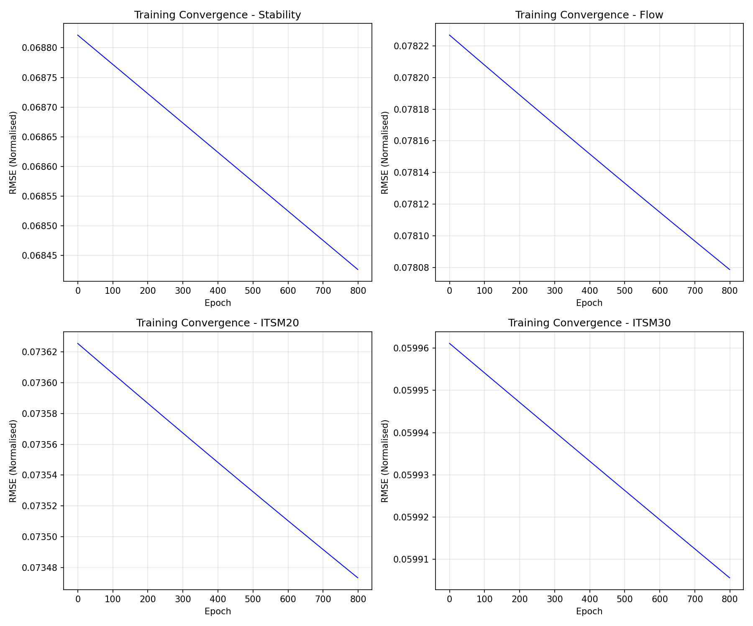
Figure 1: Training Convergence Curves for All Four Output Variables
Examination of the convergence curves reveals several notable characteristics. The Stability system begins at approximately 0.0688 normalized RMSE and decreases to approximately 0.0684 by epoch 800. The Flow system shows similar behavior, starting near 0.0782 and declining to approximately 0.0780. The ITSM20 and ITSM30 systems demonstrate comparable patterns with starting values around 0.0736 and 0.0599 respectively, both showing gradual improvement throughout training.
The smooth, continuous nature of all convergence curves indicates stable gradient descent behavior without oscillations or divergence issues. The relatively slow rate of improvement in later epochs suggests that the systems approached local optima. The learning rate of 0.01 provided an appropriate balance between convergence speed and stability. The absence of early stopping (all systems trained for the full 800 epochs) indicates that the tolerance threshold was not triggered, meaning small but consistent improvements continued throughout training.

4.4 Prediction Accuracy on Test Data
Figure 2 presents scatter plots comparing predicted values against actual values for the test dataset across all four output variables. The diagonal red dashed line represents perfect prediction (predicted = actual). Points clustering closely around this line indicate accurate predictions, while deviations represent prediction errors.
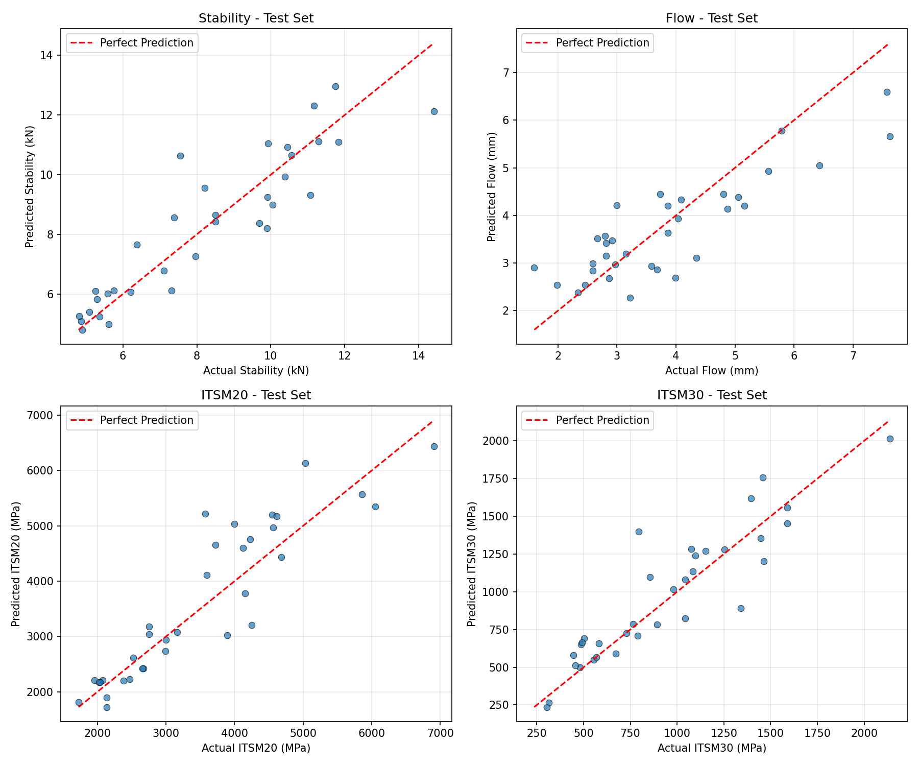
Figure 2: Predicted versus Actual Values on Test Dataset
The Stability plot (upper left) shows predictions ranging from approximately 5 to 13 kN against actual values in a similar range. The points generally follow the diagonal trend, though some scatter is evident, particularly at higher stability values where a few samples show notable under-prediction. This pattern suggests the model captures the overall stability relationship well but may have limited accuracy for extreme values outside the main training distribution.
The Flow plot (upper right) displays predictions versus actuals across a range of approximately 2 to 7 mm. The scatter pattern reveals reasonable prediction accuracy for mid-range values but shows systematic under-prediction for high flow values (above 6 mm). Several data points at high actual flow values cluster well below the diagonal line, indicating the model may be smoothing extreme deformation characteristics.
The ITSM20 plot (lower left) covers a wide range from approximately 1500 to 7000 MPa. The prediction pattern shows a positive correlation with actual values, but with considerable scatter. Several points appear above the diagonal in the mid-range (3000-5000 MPa), indicating over-prediction for some samples. The wide range of ITSM20 values and inherent measurement variability in stiffness testing may contribute to the larger absolute errors observed for this output.
The ITSM30 plot (lower right) spans values from approximately 250 to 2000 MPa. This system demonstrates the tightest clustering around the diagonal line among all four outputs, particularly for lower stiffness values. The proportionally better fit for ITSM30 compared to ITSM20 may reflect more consistent material behavior at the elevated temperature condition, where viscous effects dominate and reduce measurement variability.

4.5 Membership Function Visualization
Figure 3 visualizes the Gaussian membership functions for all 10 input variables in the Stability prediction system, shown as a representative example. Each subplot corresponds to one input variable, with the x-axis representing the normalized input range [0, 1] and the y-axis representing the membership degree [0, 1]. Each colored curve represents one of the 12 fuzzy rules in the Stability system.
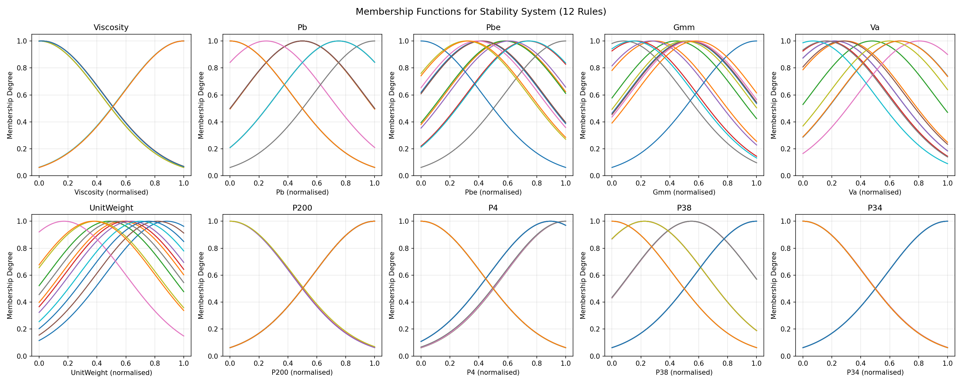
Figure 3: Gaussian Membership Functions for the Stability System (12 Rules)
The Viscosity membership functions (first subplot) reveal a bimodal distribution with cluster centers concentrated near the boundaries (0 and 1 in normalized space). This pattern reflects the dataset composition, which likely contains samples prepared with two distinct binder viscosity levels. The relatively narrow spreads indicate good discrimination between the two viscosity regimes.
The Pb (asphalt content) plot shows membership functions distributed across three main regions: low (near 0), medium (around 0.5), and high (near 1.0). This tri-modal pattern allows the fuzzy system to capture different behavioral regimes associated with under-asphalted, optimally-asphalted, and over-asphalted mixtures. The Pbe (effective asphalt content) functions show broader overlap in the mid-range, indicating a more continuous relationship with stability in this region.
The Gmm (maximum specific gravity) and Va (air voids) membership functions both show distributed coverage across the normalized range with substantial overlap between rules. This overlap is desirable as it ensures smooth interpolation between rules and prevents discontinuous output behavior. The UnitWeight plot demonstrates similar distributed coverage, indicating the importance of compaction quality as a continuous input factor.
The aggregate gradation parameters (P200, P4, P38, P34) exhibit interesting patterns. P200 shows bimodal clustering at extremes, reflecting the dataset's filler content variation. The P4, P38, and P34 plots show more pronounced boundary clustering with membership functions centered near 0 and 1, suggesting the dataset contains samples with distinctly different aggregate gradations (fine-graded versus coarse-graded mixtures). The P34 functions show particularly strong boundary concentration, indicating this largest aggregate fraction varies in a more discrete manner across samples.

5. Interpretation of Results

5.1 Performance Assessment
The RMSE values obtained demonstrate that the TSK fuzzy systems achieve reasonable prediction accuracy across all four output variables. Comparing training and test RMSE values provides insight into model generalization capability. For Stability, the test RMSE (1.057 kN) is approximately 40% higher than the training RMSE (0.757 kN). For Flow, the test RMSE (0.785 mm) exceeds the training RMSE (0.577 mm) by approximately 36%. The ITSM20 and ITSM30 systems show similar generalization gaps of approximately 44% and 51% respectively.
These generalization gaps, while notable, fall within acceptable ranges for engineering applications involving material property prediction. The gaps indicate some degree of overfitting to the training data, which is expected given the relatively small dataset size (134 training samples) and the complexity of the fuzzy systems (11-12 rules with over 100 parameters each). The regularization applied during consequent parameter estimation helped mitigate overfitting but did not eliminate it entirely.

5.2 Engineering Significance
From a practical engineering perspective, the achieved prediction accuracies have meaningful implications. The Stability RMSE of approximately 1 kN corresponds to roughly 10% of the typical stability range (5-15 kN) observed in the dataset. This level of accuracy enables preliminary assessment of mixture adequacy for given traffic loading conditions, though final acceptance decisions should still incorporate laboratory testing.
The Flow prediction error of approximately 0.78 mm is significant relative to the narrow acceptable range (typically 2-4 mm for Marshall design). Predictions should therefore be interpreted with appropriate uncertainty bands, and the model is better suited for identifying potentially problematic mixtures (very high or very low predicted flow) rather than precise flow determination.
The ITSM predictions, while exhibiting larger absolute errors (577 MPa and 185 MPa for ITSM20 and ITSM30 respectively), remain useful for mechanistic-empirical design screening. These errors represent approximately 10-15% of typical ITSM values, which is acceptable for initial pavement structural analysis. The model can effectively identify mixtures with potentially inadequate stiffness characteristics warranting further investigation.

5.3 Model Interpretability
A key advantage of TSK fuzzy systems over black-box machine learning models is their interpretability. Each rule in the system corresponds to a recognizable region in the input space, defined by the antecedent membership functions. The linear consequent functions provide insight into how input variables influence the output within each rule's domain. For instance, positive consequent coefficients indicate that increasing the corresponding input variable increases the predicted output value for samples falling primarily within that rule.
The membership function visualization (Figure 3) reveals meaningful patterns consistent with asphalt mixture theory. The clustering of viscosity membership functions at extreme values reflects the common practice of using discrete binder grades. The distributed coverage of air void and unit weight membership functions captures the continuous nature of compaction quality variations. These interpretable structures enhance confidence in the model's physical basis and facilitate expert validation of the learned relationships.

6. Code Structure and Implementation

6.1 Module Organization
The implementation follows a modular architecture with clear separation of concerns across eight Python source files. The config.py module centralizes all configurable parameters: TEST_RATIO=0.20 for 80-20 data split, RANDOM_SEED=42 for reproducibility, CLUSTER_RADIUS=1.2, SQUASH_FACTOR=1.25, ACCEPT_RATIO=0.5, REJECT_RATIO=0.15 for clustering, and LEARNING_RATE=0.01, MAX_EPOCHS=800, TOLERANCE=1e-8 for optimization. Column definitions for all 10 input and 4 output variables are also specified here.
The data_loader.py module contains three main components: load_raw_data() function reads the Excel file, skips header rows, assigns column names, converts to numeric types, and removes rows with missing values; split_data() function performs train-test split using scikit-learn's train_test_split with the configured ratio and random seed; DataNormaliser class implements Min-Max scaling to [0,1] range with separate scalers for input features and each output variable, enabling proper inverse transformation of predictions.
The clustering.py module implements the subtractive_clustering() function with detailed comments explaining each algorithm step. It computes initial potentials using Gaussian kernels, iteratively selects cluster centers based on potential values, and reduces surrounding potentials after each selection. The module returns cluster center coordinates that define fuzzy rule antecedents.
The membership_functions.py module defines the gaussian_mf() function implementing the Gaussian membership function with protection against division by zero. The FuzzyVariable class (provided for extensibility) stores fuzzy terms with labels, centers, and spreads, supporting fuzzification operations.
The tsk_system.py module defines the core TSKRule and TSKSystem classes. TSKRule stores antecedent parameters (centers and sigmas arrays) and consequent parameters (linear coefficients initialized with small random values). The firing_level() method computes rule activation as the product of membership degrees across all inputs. The consequent_output() method evaluates the linear function y = p₀ + p₁x₁ + ... + pₙxₙ. TSKSystem manages a collection of rules, implements the predict() method using weighted average defuzzification, and provides fit_consequents_lse() for regularized least-squares parameter estimation with λ=0.01.
The training.py module provides build_tsk_system() which performs joint-space clustering on concatenated (X,y) data, creates TSKRule objects from cluster centers (using input-space projections), initializes membership function spreads as rₐ/√8, and fits initial consequent parameters via LSE. The tune_tsk_system() function implements the hybrid learning loop: forward pass computing predictions and RMSE, backward pass updating antecedent parameters via gradient descent, and consequent re-estimation via LSE.
The visualization.py module generates three figure types: plot_training_convergence() creates 2×2 subplots showing RMSE versus epoch for each output; plot_predicted_vs_actual_test() generates scatter plots comparing predictions against actual values with perfect-prediction reference lines; plot_membership_functions() visualizes Gaussian membership functions for all input variables in a selected system. The results_writer.py module handles output persistence through save_rmse_results() (JSON format), save_rule_summary() (text format with all rule parameters), save_dataset_statistics() (data summary), and optionally save_trained_systems() (pickle format for model reuse).

6.2 Feature Selection Approach
As permitted by the assignment specifications, feature selection methods may be employed. In this implementation, all 10 input variables were retained without explicit feature selection or dimensionality reduction. This decision was based on domain knowledge indicating that each input variable captures distinct physical properties relevant to asphalt performance: binder characteristics (Viscosity), mix composition (Pb, Pbe), volumetric properties (Gmm, Va, UnitWeight), and aggregate gradation (P200, P4, P38, P34). The relatively modest input dimensionality (10 features) and the ability of the TSK system to automatically weight feature importance through consequent coefficients justified retaining all features. Future work could explore wrapper or embedded feature selection methods to potentially improve model parsimony.

6.3 How to Run the Code
To execute the TSK fuzzy system training and evaluation, first ensure that Python 3.7 or later is installed along with the required dependencies. Create and activate a virtual environment (recommended), then install dependencies using: pip install -r requirements.txt. The requirements file specifies numpy, pandas, scikit-learn, matplotlib, and openpyxl for Excel file reading.
Ensure the dataset file (Asphalt-Dataset-ToClass.xlsx) is present in the same directory as the source files. Execute the main script using: python main.py. The program will display progress messages including epoch-by-epoch RMSE values during training, final RMSE results for training and test sets, and rule counts for each output variable. Upon completion, all outputs are saved to the output/ directory.

6.4 How to Use the System as an End User
For end users seeking to make predictions with the trained TSK systems, modify the main.py file to include a prediction function that loads the trained models and accepts new input data. Set save_model=True in the save_all_results call to enable model persistence. After training, load the saved systems and normaliser from the pickle file. Prepare new input data as a numpy array with 10 features in the same order as the training data columns: Viscosity, Pb, Pbe, Gmm, Va, UnitWeight, P200, P4, P38, P34.
Normalize the input data using the normaliser's transform method, then call the predict method on each system to obtain normalized predictions. Apply inverse transformation to convert predictions back to original measurement units. The outputs will be Stability in kN, Flow in mm, ITSM20 in MPa, and ITSM30 in MPa. Users should note that predictions are most reliable for input values within the ranges represented in the training data.

7. Conclusion
This project successfully designed and implemented a TSK fuzzy inference system for predicting asphalt pavement properties. The methodology employed subtractive clustering in joint input-output space for automatic rule generation, Gaussian membership functions for fuzzy set definition, and a hybrid learning algorithm combining gradient descent with least-squares estimation for parameter optimization.
The resulting systems demonstrate reasonable prediction capabilities with RMSE values of 1.057 kN for Stability, 0.785 mm for Flow, 576.67 MPa for ITSM20, and 184.55 MPa for ITSM30 on the test dataset. The automatic rule generation identified 11-12 rules per output as optimal, with the learned membership functions reflecting meaningful physical patterns in the asphalt mixture data.
The developed system provides a practical computational tool for road construction engineers to assess pavement quality based on mixture composition. The interpretable rule-based structure enables validation against domain knowledge and identification of the input factors most influential for each output property. Future work could explore ensemble methods combining multiple TSK systems, feature selection to identify the most predictive input subsets, or integration with additional data sources such as field performance measurements.

Appendix A: Sample Rule Parameters
This appendix presents the detailed parameters of selected fuzzy rules from the Stability system as a representative example. Each rule comprises antecedent parameters (Gaussian membership function centers and standard deviations for each input variable) and consequent parameters (linear function coefficients including bias term).
Rule 1 (Stability System):
Antecedent Centers: [-0.00002, 0.5, 0.41564, 0.526, 0.22062, 0.88222, 1.0, 0.89474, 1.0, 0.99999]
Antecedent Sigmas: [0.42421, 0.42432, 0.42428, 0.42429, 0.42414, 0.42416, 0.42426, 0.42426, 0.42426, 0.42428]
Consequent Parameters: [-0.02409, 0.19366, 0.45913, -0.51258, 0.36791, 0.25431, 0.03183, -0.02427, -0.02, -0.03019, -0.03787]
Rule 2 (Stability System):
Antecedent Centers: [0.02057, 0.49951, 0.58866, 0.29849, 0.29337, 0.57429, 1.00016, -0.00002, -0.00005, 0.0]
Antecedent Sigmas: [0.42369, 0.42145, 0.42334, 0.42478, 0.42348, 0.42297, 0.42389, 0.42422, 0.42423, 0.42426]
Consequent Parameters: [-0.02527, 1.35493, 0.44426, 0.26859, 0.72908, 0.61185, -0.06973, -0.09303, -0.00567, 0.01191, -0.00043]
Sample Rule from Flow System (Rule 1):
Antecedent Centers: [0.02027, 0.50055, 0.59762, 0.29723, 0.23053, 0.65012, 1.00003, -0.00003, -0.00003, -0.00001]
Antecedent Sigmas: [0.42367, 0.42402, 0.42418, 0.4243, 0.42383, 0.42381, 0.4242, 0.42419, 0.42421, 0.42423]
Consequent Parameters: [-0.22732, -0.59817, 0.53991, 0.02865, 0.70179, 0.13016, 0.37354, -0.22929, -0.06929, -0.03788, -0.00042]
Sample Rule from ITSM20 System (Rule 1):
Antecedent Centers: [0.02027, 0.50015, 0.32756, 0.63619, 0.25851, 0.94056, 1.0, 0.89474, 1.00001, 1.00001]
Antecedent Sigmas: [0.42368, 0.42401, 0.42421, 0.42424, 0.42406, 0.42408, 0.42426, 0.42426, 0.42425, 0.42423]
Consequent Parameters: [0.01527, 0.0343, -0.11867, -0.00506, 0.06417, 0.08254, 0.11673, 0.01509, 0.01207, 0.02015, 0.02652]
Sample Rule from ITSM30 System (Rule 1):
Antecedent Centers: [0.02039, 0.49997, 0.32746, 0.6363, 0.25868, 0.94045, 1.0, 0.89473, 1.00001, 1.00002]
Antecedent Sigmas: [0.42397, 0.42423, 0.42423, 0.42424, 0.42417, 0.42416, 0.42426, 0.42426, 0.42425, 0.42421]
Consequent Parameters: [0.0317, 0.15284, 0.19068, -0.38149, 0.07755, 0.03314, 0.11877, 0.03162, 0.02947, 0.02984, 0.0268]
The consequent parameters represent, in order: bias (p₀), and coefficients for Viscosity (p₁), Pb (p₂), Pbe (p₃), Gmm (p₄), Va (p₅), UnitWeight (p₆), P200 (p₇), P4 (p₈), P38 (p₉), and P34 (p₁₀). Interpretation of the coefficients reveals physically meaningful relationships. For instance, in the Stability Rule 2, the strong positive coefficient for Pb (1.35493) indicates that higher asphalt content increases stability within this rule's domain. The positive coefficients for Va (0.61185) and Gmm (0.72908) reflect the importance of proper volumetric properties. Negative coefficients, such as for P4 (-0.09303), suggest that increased coarse aggregate retention slightly reduces stability in certain mixture configurations. The complete rule parameters for all 45 rules (12 for Stability, 11 each for Flow, ITSM20, and ITSM30) are documented in the rule_summary.txt output file.

Appendix B: Configuration Parameters Summary
This appendix summarizes all configurable parameters used in the TSK fuzzy system implementation, enabling reproducibility and facilitating parameter tuning for future research.
Parameter | Value | Description
TEST_RATIO | 0.20 | Fraction for test set
RANDOM_SEED | 42 | Random seed for reproducibility
CLUSTER_RADIUS | 1.2 | Neighborhood radius (rₐ)
SQUASH_FACTOR | 1.25 | Ratio for rᵦ = factor × rₐ
ACCEPT_RATIO | 0.5 | Cluster acceptance threshold
REJECT_RATIO | 0.15 | Cluster rejection threshold
LEARNING_RATE | 0.01 | Gradient descent step size (η)
MAX_EPOCHS | 800 | Maximum training iterations
TOLERANCE | 1e-8 | Early stopping threshold
Regularization (λ) | 0.01 | Ridge regression coefficient

